**Group: NoName**

1. **Interview Summary**
   1. **What went well**
      1. One thing that I thought went well with the interview was we really got a sense of what the user actually wants in our product, and what they didn't want.
      2. Also, we gained a lot of feedback on ways we could fine tune our design of the product.
   2. **What didn’t go well**
      1. One thing that did not go well was our product can be hard to look at as a real possibility because it depends on self driving becoming safer and more popular, which it is not at this time. Because of this the interviewee might have had a hard time looking at the Tesla Looking Glass as a realistic possibility.
         1. One way to fix this would be to hold off of on some of the more extreme applications like video streaming.
   3. **Summary of information collected**
      1. **What do you think of getting recommendations for services and products as you pass them on the road?**
         1. Would be pretty useful. Could pre program notify the user if certain things occur during the trip.
      2. **How would you want to navigate the screen?**
         1. **Would you like to be able to use a keyboard and/or mouse/trackpad?**
            1. Would be helpful, a touch interface
         2. **Would you want to be able to use a 3rd party wired/wireless one?**
            1. Yes - a good feature to have
      3. **Would you just want the screen to be built into the dash?**
         1. Probably up on the windshield with some opacity
      4. **Would you want to be looking at two separate windows at the same time? - Multi-tasking**
         1. Be able to see multiple screens
      5. **What information about the car would you like to have access to?**
         1. Statistics with detailed descriptions of some things
      6. **Would you mind having to open a specific folder to do so?**
         1. Yes, and perhaps a way to send it to an external device to store it away from the car
      7. **What would you want constantly displayed?**
         1. Would want what's commonly on a dash - charge, tire pressure, etc.
      8. **Would you prefer the screen to be just on the passenger side, or to cover the entire front windshield?**
         1. Partially used, being able to see without obstruction.
      9. **How transparent would you like the screen to be while driving?**
         1. Situation-dependent, have the option to change it.
      10. **Would you want to be able to change that?**
          1. Yes
      11. **If given the opportunity to use our Looking Glass product, what feature or service would you be most interested in using? Email, searching the web, replying to messages, navigation?**
          1. Navigation connecting into the self-driving aspect.
          2. Email
          3. YouTube or reddit
      12. **Are there any other features you would like to see included in the Looking Glass?**
          1. One way screen so people outside the car can’t see it.
          2. Connecting through a phone plan.
          3. 360 degree view
2. **Prioritized set of requirements**
   1. **Functional**
      1. The Looking Glass can be activated when the Tesla is in park or self-drive mode and the Looking Glass button is pressed
      2. The Looking Glass will have motion detection for hand gestures
      3. The Looking Glass will have voice recognition for verbal commands
      4. The Looking Glass shall display emails to the user
      5. The Looking Glass shall display text messages to the user
      6. The Looking Glass can use various applications such as Spotify, Netflix, and Youtube
      7. The Looking Glass can connect to the users phone via Bluetooth
      8. The Looking Glass can display the users phone notifications
      9. The Looking Glass will display advertisements for nearby establishments
      10. The Looking Glass will display GPS navigations either over the entire screen or in a simplified display on the bottom
      11. When the driver is actively driving the car, simplified widgets will be displayed on the bottom of the windshield
   2. **Non-Functional**
      1. The Looking Glass will be transparent at all times while the car is not in park
      2. The Looking Glass display will immediately shut off the moment the driver takes control of the wheel, or self-drive mode is turned off
      3. The Looking Glass display will only be visible to those inside the vehicle
   3. **System Models**
      1. **Context Model**

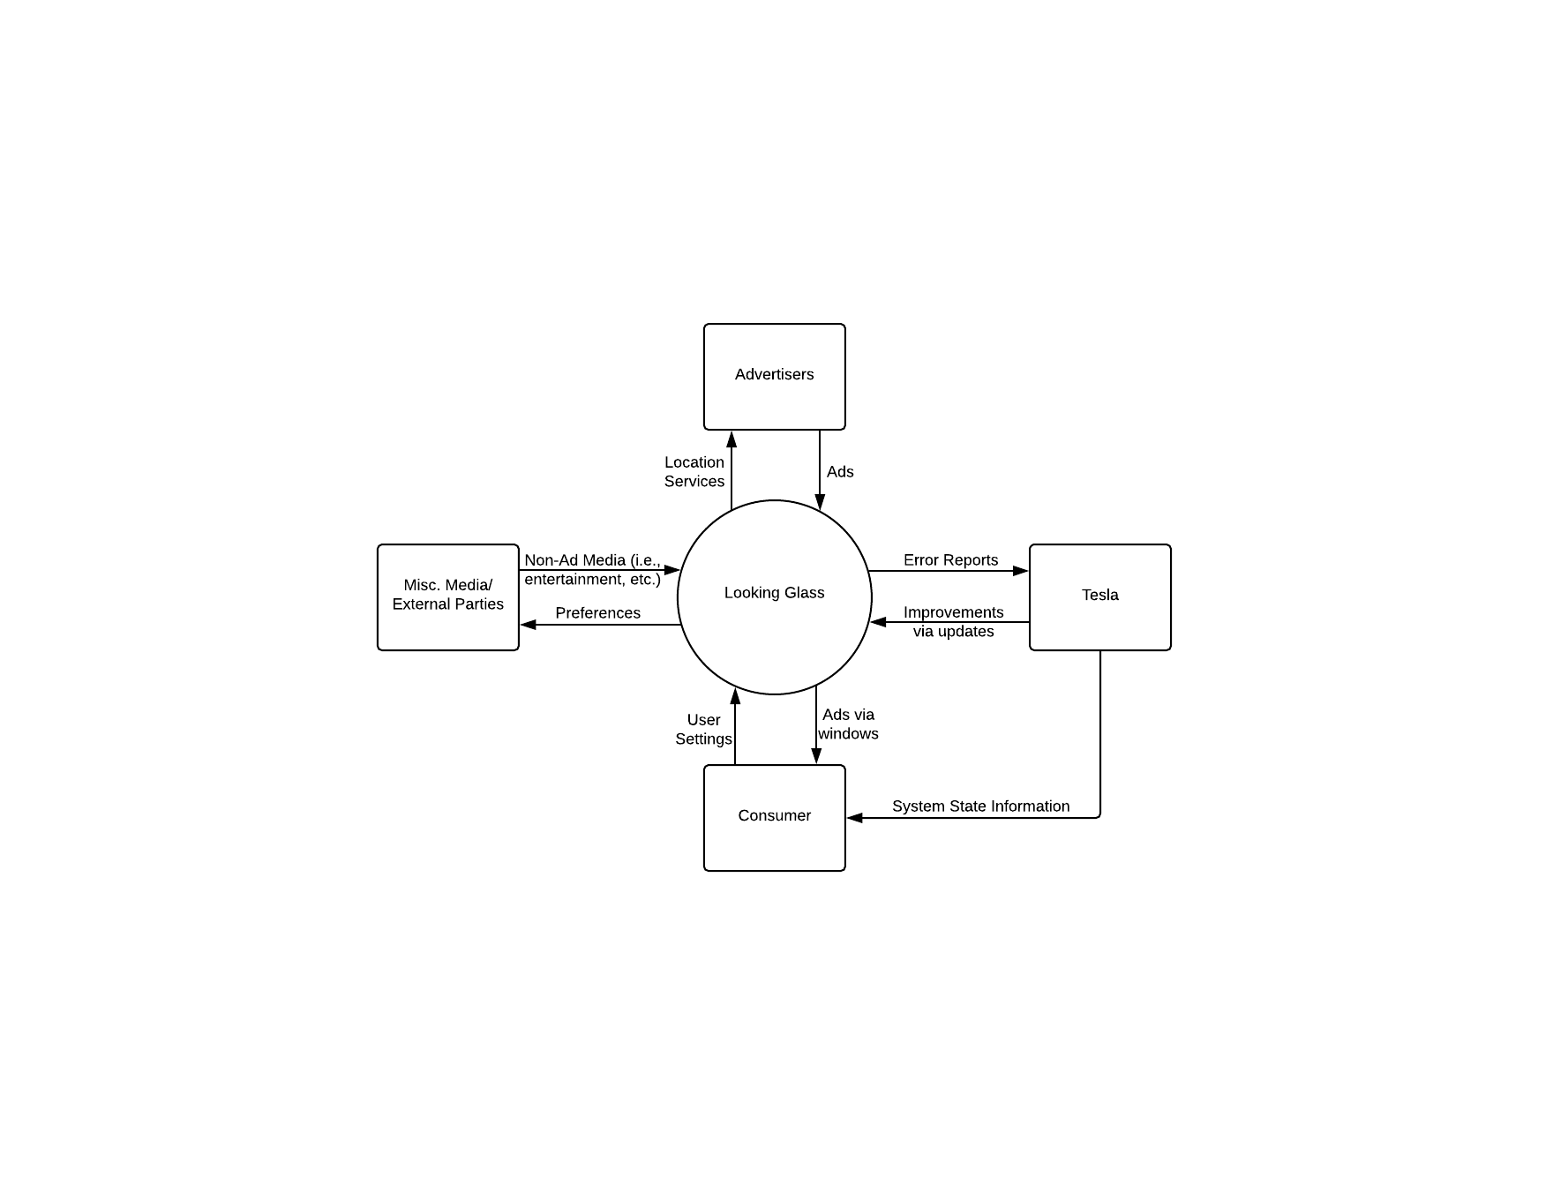

1. **Scenario (Most important use of product and why)** 
   1. Driver enters Car and begins driving to work
   2. Driver pulls onto freeway into stop and go traffic
   3. Driver puts Tesla into self-drive mode and takes hands off of steering wheel
   4. Driver pushes Looking Glass button
   5. Looking Glass display lights up and shows available applications on window
   6. Driver clicks email application
   7. Driver reads through work emails
   8. Driver decides to reply to one, so they point in the direction of the reply button, and then click the voice command button
   9. Driver verbally says what to reply and the voice command transfers the information into the email text box.
   10. Driver motions to send email
   11. Driver motions to exit out of email app
   12. Driver puts hands back on steering wheel which turns the Looking Display off
   13. Driver pulls off of freeway, and drives the rest of the way to work

* **Why:** This is the most important feature because the Looking Glass display is targeted towards business men and women who are in traffic before and after work. This will help them to stay productive.

1. **Storyboard**

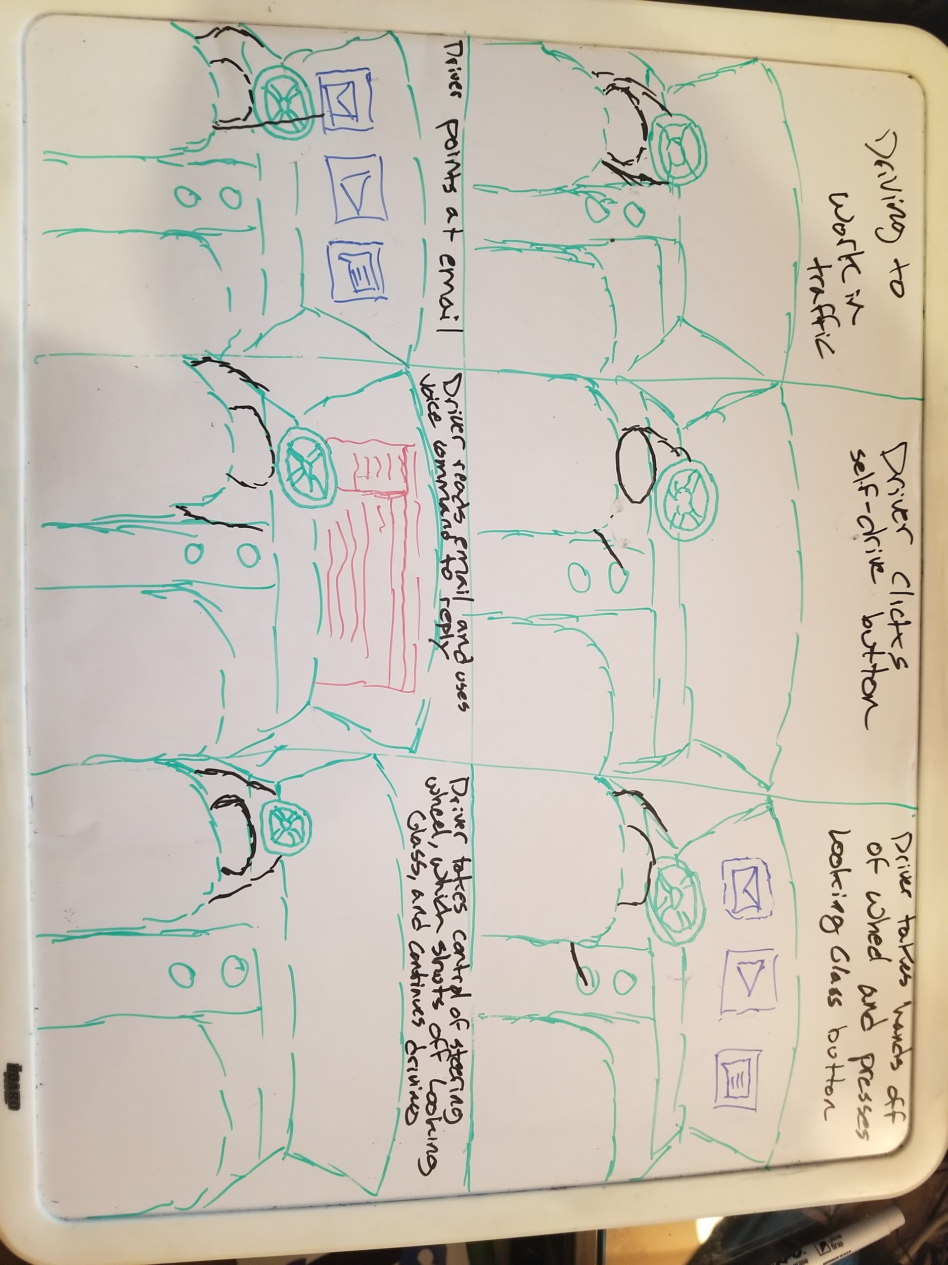

1. **Individual functional and non-functional specifications (1 of each per person)**
   1. **Caleb**
      1. **Functional**
         1. **Function:** Turn on Looking Glass Display
         2. **Description:** Turns on Looking Glass Display when driver clicks Looking Glass display button is pressed
         3. **Inputs:** Looking Glass button is pressed, and Self-Driving/park mode button is pressed
         4. **Source:** Driver
         5. **Outputs:** Looking Glass Display is turned on
         6. **Destination:** Front windshield
         7. **Action:** If Looking Glass button is pressed and all other safety prerequisites are met, then the display will turn on and await further actions from driver.
         8. **Requires:** Tesla is in either park or self-drive mode, and drivers hands are not on the steering wheel
         9. **Precondition:** The Looking Glass Display is off
         10. **Postcondition:** Looking Glass Display is on, as well as motion sensors
      2. **Non-Functional**
         1. **Function:** Turn off Looking Glass display
         2. **Description:** Turns off Looking Glass display when driver is driving
         3. **Inputs:** Self-Drive off button, steering wheel sensors
         4. **Source:** Driver
         5. **Outputs:** Looking Glass display turns off
         6. **Destination:** Front windshield
         7. **Action:** If driver turns off self-drive mode or takes control of the steering wheel then the Looking Glass display will turn off.
         8. **Requires:** Driver to be in control of vehicle
         9. **Precondition:** Car is in self-drive mode and Looking Glass display is on.
         10. **Postcondition:** Driver either pushes to turn off self-drive mode or takes control of the steering wheel which turns off the Looking Glass display
   2. **Michael**
      1. **Functional**
         1. **Function:** Open and/or show applications that the user points to.
         2. **Description:** When the user points their index finger at an app shortcut or window on the screen, that app will be opened if it isn’t already and have focus.
         3. **Inputs:** The user’s index finger pointing to something on the UI.
         4. **Source:** The user.
         5. **Outputs:** The app running and getting focus.
         6. **Destination:** The screen on the windshield.
         7. **Action:** The hand gesture subsystem recognizes that the user is pointing towards the screen with their index finger. The coordinates of where their finger is pointing at is sent to the application manager. The application manager checks what UI components are intersecting that point. The component on the highest layer is selected as the one being interacted with. If that component is an app shortcut, the corresponding app is opened and given focus. If the component is an app window, then the window is given focus.
         8. **Requires:** Recognition of user input. An app on the UI that is inline with the user’s index finger.
         9. **Precondition:** The windshield screen is on, and the UI is currently displaying app shortcuts.
         10. **Postcondition:** The subsystem that recognizes hand gestures is ready to recognize another command. The previous app that had focus doesn’t have it now and is one layer below the one with focus.
      2. **Non-Functional**
         1. **Function:** The Looking Glass OS cannot write to the car’s OS.
         2. **Description:** any interaction between the two is strictly a request for one way output from the car’s OS.
         3. **Inputs:** Data from the car’s OS.
         4. **Source:** The car’s OS.
         5. **Outputs:** Information from the car’s OS is given to the Looking Glass OS.
         6. **Destination:** The function inside the Looking Glass OS that requested the data.
         7. **Action:** A function within the Looking Glass OS requests some kind of data that is allowed to be accessed from the car’s OS, like MPH, and the car’s OS returns that data.
         8. **Requires:** A read only connection from the Looking Glass OS to the car’s OS. There should be no way to write to the car’s OS.
         9. **Precondition:** There’s valid data to read.
         10. **Postcondition:** Nothing changed within the car’s OS.
   3. **Chandler**
      1. **Functional**
         1. **Function:** Sending an error report.
         2. **Description:** If there is a bug or glitch that the user determines to be hindering to the overall experience, they are able to send Tesla an error report detailing what went wrong.
         3. **Inputs:** The error message and any additional comments/suggestions they believe can improve/solve the problem.
         4. **Source:** The user.
         5. **Outputs:** A confirmation message message.
         6. **Destination:** Tesla.
         7. **Action:** Sending the user-created error message to an actual Tesla employee.
         8. **Requires:** An actual problem/bug.
         9. **Precondition:** The user experienced anything they believed to be an error while using Looking Glass.
         10. **Postcondition:** Nothing.
   4. **Non-Functional**
      * 1. **Function:** Handling a crash.
        2. **Description:** What the system does in the event of a crash resulting in a system restart.
        3. **Inputs:** Error codes..
        4. **Source:** System.
        5. **Outputs:** Error messages/restart warning.
        6. **Destination:** Looking Glass/main display.
        7. **Action:** Looking Glass restarts itself.
        8. **Requires:** Crash scenarios appropriately handled by developers.
        9. **Precondition:** System Crashes.
        10. **Postcondition:** System Restarts.
   5. **Alnur Elberier**
      1. **Functional**
         1. **Function:** Change screen opacity
         2. **Description:** Increases and decreases the percentage of transparency
         3. **Inputs:** User inputs desired opacity percentage through knob on dash
         4. **Source:** Driver
         5. **Outputs:** Looking Glass opacity is manipulated
         6. **Destination:** Front windshield
         7. **Action:** If the opacity dial is turned and all other safety prerequisites are met, then the display will become more or less transparent
         8. **Requires:** Tesla is in either park or self-drive mode, and drivers hands are not on the steering wheel
         9. **Precondition:** The Looking Glass Display is not at the desired opacity
         10. **Postcondition:** Looking Glass Display is now on the desired percent opacity
      2. **Non-Functional**
         1. **Function:** Notify the user of pertinent incoming information in real time
         2. **Description:** Flashes a notification in the top right corner of the screen for 15 seconds or until the notification is dismissed.
         3. **Inputs:** A time sensitive message for the driver of the car
         4. **Source:** User accepted notification sources, and system required notification sources (aka the systems that monitor the functionality of the cars mechanics)
         5. **Outputs:** Looking Glass displays a notification box along with a notification tone in the top right corner of the screen within seconds of receiving the notification
         6. **Destination:** Front windshield top right corner, and speakers for optional audio output
         7. **Action:** If a message is received from one of the approved notification sources it is displayed to the screen
         8. **Requires:** Information from a source
         9. **Precondition:** Car is on and Looking Glass display is on. Source is an approved source of notification information
         10. **Postcondition:** A notification is displayed within milliseconds of it being received, tho which the user can dismiss or open to view more information.